

June 7, 2011

Senator Michael D. Crapo
United States Senate
Washington, DC 20510

Senator Crapo:
TESTER/CORKER “COMPROMISE ON SWIPE FEES IS WORSE FOR RETAILERS AND CONSUMERS THAN ORIGINAL BILL
Under the guise of “compromise” and “moderation,” Senators Tester and Corker have put forth legislation on debit card swipe fee reform legislation that would be a disaster for merchants and consumers and a windfall for the banking industry.
This legislation, that appears to have been written from a credit card industry wish list, would REQUIRE fees to be charged for debit card usage that FAR EXCEED current fees…fees that are already higher for American merchants and consumers than anywhere else in the world.
Additionally, it requires a study based purely on speculation. All that is required for new rules to be created is the “possibility” that the fallacious doom and gloom predictions put forth by bank lobbyists MIGHT happen. A proper study would look at what is “actually” happening after reforms being put forth by the Federal Reserve take place. Why is the Tester/Corker amendment being brought up before the final Federal Reserve rules are even published?
As I wrote to you yesterday, on behalf of the over 146,000 American convenience stores and our millions of customers (5.4 million of whom signed petitions last year calling for swipe fee reform), the National Association of Convenience Stores will be KEY VOTING AGAINST THE TESTER/CORKER SWIPE FEE AMENDMENT.
I respectfully ask for your NO VOTE on this piece of legislation.
Sincerely,
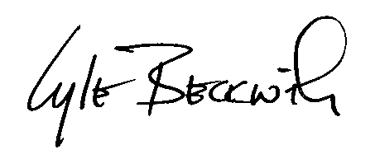
Lyle Beckwith
Sr. Vice President, Government Relations

